

**Chapter 2**

**Expressions and Conditionals**

* A fragment of code that produces a value is called an expression. Every value written literally is an expression, e.g., 77 or “Manas”.

**Operators**

1. **Arithmetic Operators**

|  |  |
| --- | --- |
| + | Addition |
| - | Subtraction |
| * | Multiplication |
| / | Division |
| ** | Exponentiation |
| % | Modulus |
| ++ | Increment |
| -- | Decrement |

1. **Assignment Operators**

|  |  |
| --- | --- |
| = | X = Y |
| += | X = X + Y |
| -= | X = X – Y |
| *= | X = X * Y |
| /= | X = X / Y |
| %= | X = X % Y |
| **= | X = X ** Y |

1. **Comparison Operators**

|  |  |
| --- | --- |
| == | Equals to |
| != | Not equals to |
| === | Equal value and type |
| !== | Not equal value or not equal type |
| > | Greater than |
| < | Less than |
| >= | Greater than or equal to |
| <= | Less than or equal to |

1. **Logical Operators**

|  |  |
| --- | --- |
| && | Logical and |
| || | Logical or |
| ! | Logical not |

1. **Ternary Operators**

* Evaluate a condition and executes a block of code based on the condition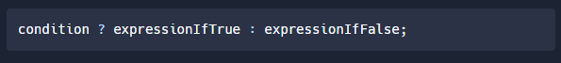
* Example Syntax of Ternary Operators looks like this:

***If Age is Greater than or equals to 18, You can Drive, else you cannot***

**Comments in JavaScript**

* Sometimes we want our programs to contain a text which is not executed by the JavaScript Engine, such a text is called comments in JavaScript.
* A comment in JavaScript can be written as follows: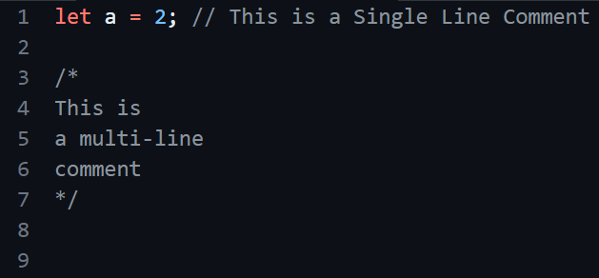
* Sometimes comments are used to prevent the execution of some lines of code:

